**CONCEPTUAL DESIGN DOCUMENT**

By

Alex Reinert

Submitted to Dr. Isenberg and Dr. Adams  
of Embry-Riddle Aeronautical University  
in Partial Fulfillment of the Course Requirements for ME 407 and COM 420

9/29/23

# ABSTRACT

The following document introduces the design that is a solution to the problem statement below. The design’s components and features will be discussed and detailed explanation of how they solve the requirements to the problem.

TABLE OF CONTENTS

ABSTRACT 1

1.0 PROBLEM STATEMENT 3

2.0 REQUIREMENTS 3

2.1 FUNCTION 3

2.2 INTERFACING 3

2.3 SAFETY 3

3.0 SYSTEM OVERVIEW 3

3.1 CONCEPT OF OPERATIONS 3

3.2 SYSTEM DESIGN 4

3.2.1 Composite Bed 4

3.2.2 Tri-Star Wheel 4

3.2.3 Spring-Backing 4

3.2.4 Electronics 5

3.2.5 Software 5

3.3 OTHER SOLUTIONS 5

3.3.1 Stair Climber for Caskets 5

4.0 CONCLUSION 5

5.0 APPENDIX 5

6.0 ACKNOWLEDGEMENTS 6

7.0 REFERENCES 6

# PROBLEM STATEMENT

Transporting heavy furniture up and down the stairs is difficult and potentially dangerous.

2.0 REQUIREMENTS

## 2.1 FUNCTION

To achieve the goal set by the problem statement, the requirements of function are as follows:

2.1.1 - The system shall transport furniture repeatedly up and down one floor within a residential building.

2.1.2 - The system shall accommodate up to a 4-seater sofa.

2.1.3 - The system shall accommodate up to a 5-shelf bookshelf.

2.1.4 - The system shall be reusable.

## 2.2 INTERFACING

To ensure that the system is of a proper size that is capable of being transported and capable of fitting within the stairwells it operates in, the requirements of interface are as follows:

2.2.1 - The system shall fit within a standard stairway according to Section R311.7.1 of the 2021 International Residential Code (IRC)

2.2.2 - The system shall be transportable in the back of an average American pickup truck in addition to the transported furniture.

## 2.3 SAFETY

To ensure that the system is overall safe, and does not endanger the operator or environment, the requirements of safety are as follows:

2.3.1 - The system shall cause less injury and strain than an average moving job.

2.3.2 - The system shall not destructively alter the environment.

2.3.3 - The system shall not damage the furniture.

# 3.0 SYSTEM OVERVIEW

## 3.1 CONCEPT OF OPERATIONS

The standard practice for using the proposed device is as follows: First, the user will load the furniture onto the flat platform and put on securing straps to ensure the furniture is stable. Second, the user will place it in front on the stairs. Third, the user will turn on the hardware and motors will begin to run. Fourth, the ultrasonic sensor will detect a stairway and begin increasing speed to the motors. Fifth, the tilt sensor will sense that we are approaching a landing and will slow down the motors. Sixth, the system will stop after reaching the landing. Finally, the straps will be removed, and furniture will be picked up and placed where it is needed.

## 3.2 SYSTEM DESIGN

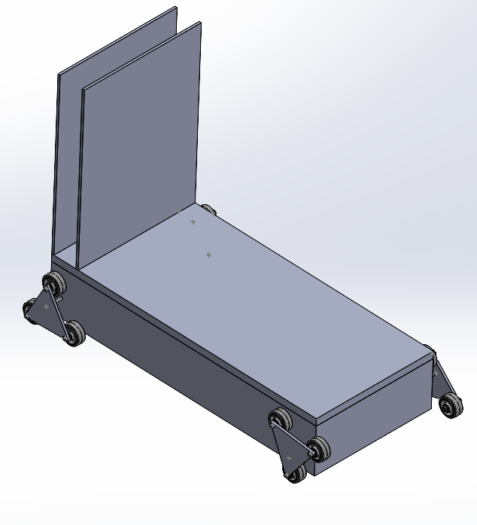

Tri-Star Wheel

Electronic Storage

Composite Bed

Spring-Backing

### 3.2.1 Composite Bed

The system includes a flat platform where the furniture is set and secured before operation. The furniture rests on the flat platform and is kept secure with straps ensuring both the safety of the furniture itself and the environment around it, satisfying requirements 2.3.2 and 2.3.3. The platform is sized so that its width does not exceed 26.5 inches and 60 inches long. This is big enough to support a 4-seater sofa and a 5-shelf bookshelf, satisfying requirements 2.1.2 and 2.1.3. This will also fit into the back of a pickup truck and meet the standard of the minimum width of a stairwell according to the IRC residential code, this satisfies requirements 2.2.1 and 2.2.2.

### 3.2.2 Tri-Star Wheel

The system is driven by four DC motors attached to four triangles. The motor drives an axle located at the center of each triangle. The system also includes three wheels attached by an axle to each point on the triangle. Both feature’s help meet requirement 2.1.1.

### 3.2.3 Spring-Backing

The system is fitted with four compression springs in between two rectangular plates, which provides support to the system. This Spring-Backing can compress to support heavy weight moving up or down the stairs, satisfying requirement 2.1.4.

### 3.2.4 Electronics

The system is fitted with a rechargeable battery located in the Electronic Storage, which provides the necessary power to the rest of the system satisfying requirement 2.1.4. The system also includes two sensors, an ultrasonic sensor and a tilt sensor, this will ultimately control the motor speed, satisfying requirements 2.3.1 and 2.3.3. The system also includes four DC motors that turn the Tri-Star Wheel, satisfying requirement 3.3.1.

### 3.2.5 Software

The software design is to take input from the ultrasonic sensor to see how far away the staircase is and a tilt sensor to detect when we are on a landing or on the stairs. It then takes this information to compute the appropriate motor speed in order to elevate up the stairs.

## 3.3 OTHER SOLUTIONS

### 3.3.1 Stair Climber for Caskets

Tri-Star Wheel

The image above is the Stair Climber for Caskets invented by Samuel Polumbo. This design is not powered and intended for a user to grab the handles and pull the device up the stairs. It moves up the stairs with the Tri-Star Wheel pivoting up each step.

# 4.0 CONCLUSION

From the above features and components, the system can safely and securely move furniture up or down the stairs. It can accommodate the intended furniture that is to be placed on it and not endanger the user of the system.

# 

# 5.0 APPENDIX

|  |  |  |  |  |  |  |
| --- | --- | --- | --- | --- | --- | --- |
| **No.** | **Requirement** | **Verification Description** | **T** | **A** | **O** | **R** |
| 1 | 2.1.1 | Test load and trial | X |  |  |  |
| 2 | 2.1.2 | Measurement/Trial | X |  |  |  |
| 3 | 2.1.3 | Measurement/Trial | X |  |  |  |
| 4 | 2.1.4 | Repeated Trials | X |  | X |  |
| 5 | 2.2.1 | Measurement and Comparison | X |  |  | X |
| 6 | 2.2.2 | Measurement and Comparison | X |  |  | X |
| 7 | 2.3.1 | Trial, followed by Analysis and Comparison | X | X | X | X |
| 8 | 2.3.2 | Trial and Observation | X |  | X |  |
| 9 | 2.3.3 | Trial and Observation | X |  | X |  |

**T** – Test and Measurement; **A** – Analysis and Simulation;   
**O** – Observation and Inspection; **R** – Reference and Datasheet

(*Requirements verification matrix. | download table - researchgate*) [1]

# 6.0 ACKNOWLEDGEMENTS

This design directly implemented the Tri-Star Wheel from the casket stair climber, which was invented by Samuel Palumbo, found in US patent US11691660B2 [2].

# 7.0 REFERENCES

[1]  
“Requirements verification matrix. | download table - researchgate,” ResearchGate, https://www.researchgate.net/figure/Requirements-Verification-Matrix_tbl1_269163835 (accessed Sep. 28, 2023).

[2]

Palumbo JR., Samuel, “Stair Climber for Casket,” US11691660B2, Jul. 04, 2023 Accessed: Sep. 14, 2023. [Online]. Available: <https://patents.google.com/patent/US11691660B2/en?q=(stair+climber)&oq=stair+climber>